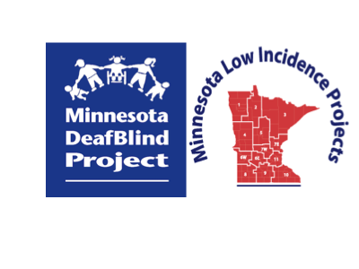

Minnesota Teachers of Students Who Are DeafBlind

Community of Practice

Monday, February 28, 2022

9:00 am - 3:00 pm
Virtual via Zoom (link will be provided to registrants prior to the event)

This workshop has no cost to participants.

Agenda:

9:00-9:15 a.m. Welcome and Updates - Introducing Brandy Johanson Sebera; Updates on the National Intervener Certification ePortfolio process; Website/YouTube
9:15-9:45 2021 National Center on Deaf-Blindness Federal Child Count - Deanna Rothbauer
9:45-10:45 IEP Discussion Guide: Determining the Need for an Intervener - Kim Simshauser
10:45-11:00 Break
11:00 - 12:00 The Basic Human Need for Closure and Its Impact
on Children and Youth Who Are DeafBlind - Maurice Belote

12:00 - 1:00 Lunch Break
1:00 - 1:30 Stories from the Mainstream - Being DeafBlind in School – Patrick Vellia
1:30-2:00 One-Pagers for DeafBlind Students – Garrett Petrie, MDE – Education Specialist – Developmental Cognitive Disabilities
2:00-2:45 One-Pager Work Time; Discussion - Ideas for Increasing School Intra-Team Communication
2:45-3:00 Evaluation and March 18, 2022, workshop reminder

Registration Information
Program and Registration Contact: Ann Mayes, ann.mayes@metroecsu.org
Presenters
Maurice Belote
Maurice Belote is a graduate of the federally funded teacher training program in deafblindness at San Francisco State University and has worked exclusively in the field of deafblindness for over 40 years. Prior to joining the state deafblind project, he served for two years as a one-on-one teacher for a deafblind adolescent and another nine years as a teacher of deafblind young adults at the California School for the Blind.
Maurice just retired as the Project Coordinator of California Deafblind Services after 30 years. Maurice is a frequent presenter at state, national, and international conferences and has written extensively on educational issues specific to children and youth who are deafblind. He serves as co-chair of the National Coalition on Deafblindness, which advocates for recognition of interveners and teachers of the deafblind in federal law. His passions include ensuring that students with deafblindness leave school with effective communication systems and are fully prepared to have the same kinds of wonderful lives that any of us would wish for ourselves.
Garrett Petrie
Garrett Petrie is the state education specialist for developmental cognitive disabilities at the Minnesota Department of Education and presents about person-centered planning across the state including one-pagers to help IEP teams understand student needs at a glance.
Kim Simshauser
Kim Simshauser is currently a teacher of blind/visually-impaired working with several DeafBlind children in her district. She initially graduated from the University of Minnesota with her Master of Education with a license to teach students who are deaf/hard of hearing in 2005. In 2015, Kim graduated from Salus University with her license to teach students who are blind/visually impaired. During her time as a deaf/hard of hearing teacher and currently in her role as a teacher of blind/visually-impaired, she has worked with many students who are DeafBlind and has collaborated with special education teams in determining the need for interveners for her students.

Patrick Vellia
Patrick grew up as a DeafBlind student in the general education classroom setting on Long Island. Mainstreamed all his life, he graduated from high school in 2006 and earned his bachelor’s degree in American Sign Language with a minor in Business Administration from Gardner-Webb University in North Carolina in 2015. Patrick is also a Certified Professional in Accessibility Core Competencies (CPAAC). In his free time Patrick has completed several half Ironman triathlons, competed in open water swimming, walked 50 miles for the National Multiple Sclerosis Society, and performed with 200 other dancers during a Zumba halftime show at a Charlotte Hornets game. For his day job, he works as a catering cook for the Target Center. Patrick is also the treasurer of DeafBlind Support and Access Network and primary web developer for their website.
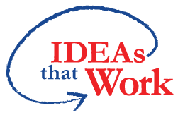 Funding for this workshop is made possible with a grant from the MN Department of Education. The source of the funds is the federal award Special Education – Programs to States, CFDA 84.027A Special Education. And federal award – Project Title: Technical Assistance and Dissemination to Improve Services and Results for Children with Disabilities CFDA 84.326T of P.L. 108-446 Individuals with Disabilities Education Act.

